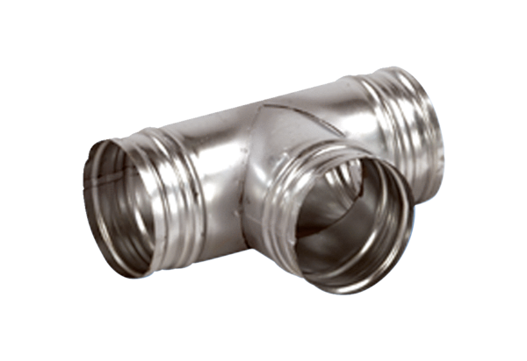90° branch AB 100-150Packing unit: 1 pieceRange: K
Article number: 0055.0351Manufacturer: MAICO

