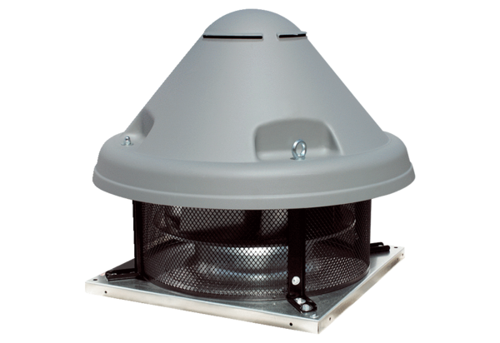Centrifugal roof fan DRD H 56/6 ExPacking unit: 1 pieceRange: C
Article number: 0073.0540Manufacturer: MAICO

