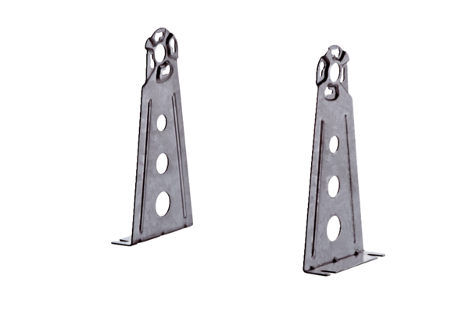Mounting foot FUR 31/1Packing unit: 1 pieceRange: C
Article number: 0036.0089Manufacturer: MAICO

