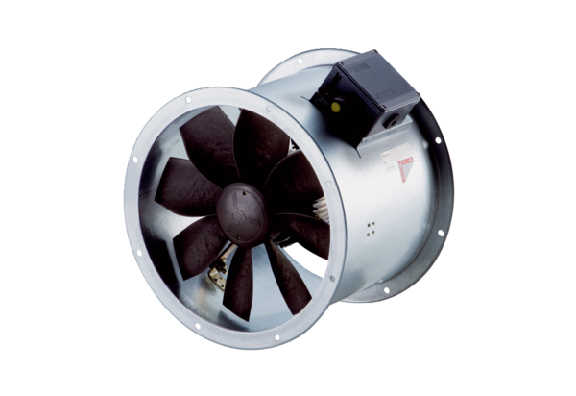Axial duct fan DZR 25/4 B Ex tPacking unit: 1 pieceRange: C
Article number: 0086.0721Manufacturer: MAICO

