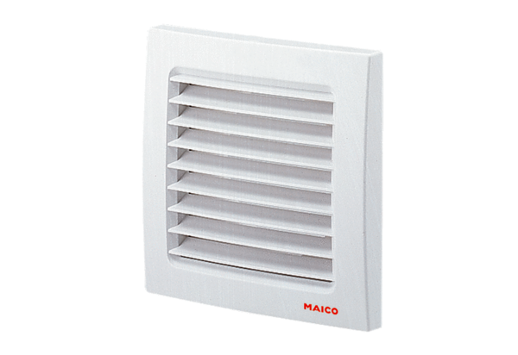External grille SG 120Packing unit: 1 pieceRange: A
Article number: 0059.0951Manufacturer: MAICO

