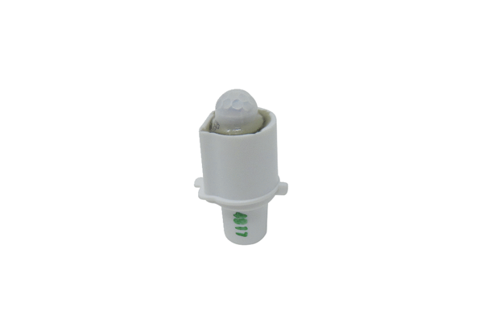Sensor SE ECA 100 ipro BRange: A
Article number: E157.0139.0000Manufacturer: MAICO

