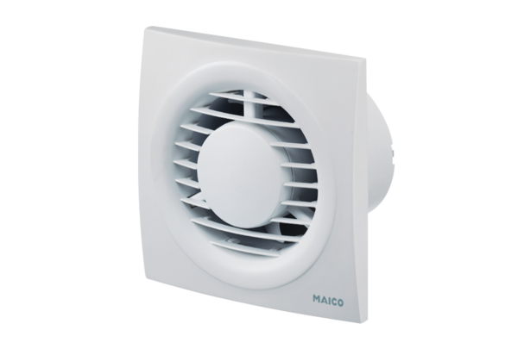Small room fan ECA piano HPacking unit: 1 pieceRange: A
Article number: 0084.0082Manufacturer: MAICO

