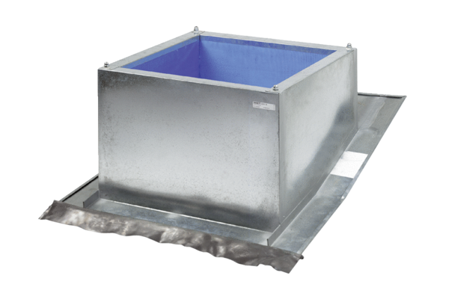Roof socket for pitched roofs SDS 50Packing unit: 1 pieceRange: C
Article number: 0093.1029Manufacturer: MAICO

