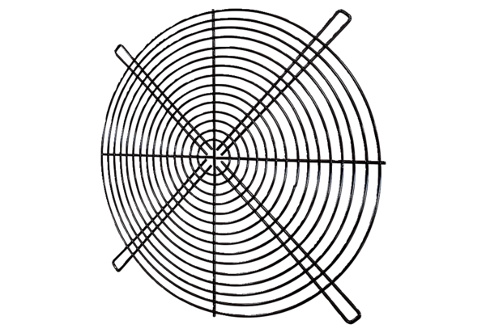Protective grille SGRI 31Packing unit: 1 pieceRange: C
Article number: 0073.0421Manufacturer: MAICO

