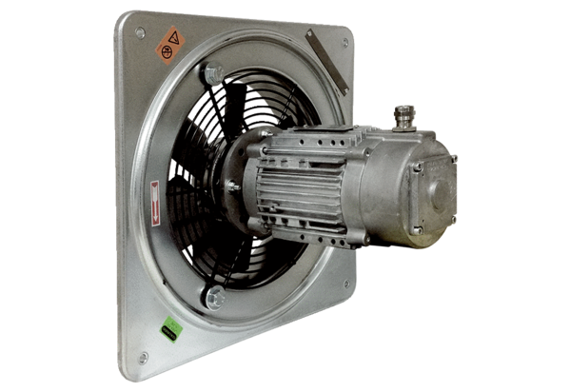Axial wall fan DAQ 71/8 ExPacking unit: 1 pieceRange: C
Article number: 0073.0339Manufacturer: MAICO

