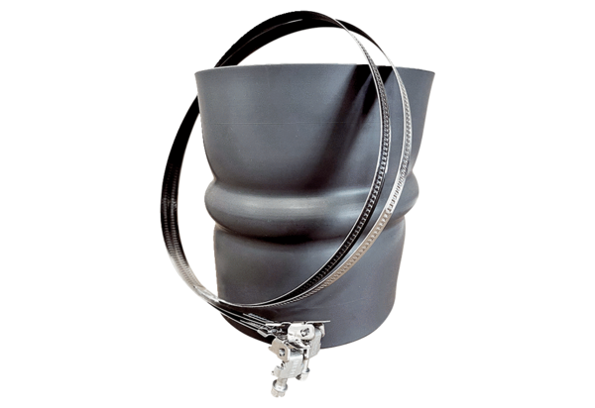Flexible cuff STKI 40Packing unit: 1 pieceRange: C
Article number: 0073.0493Manufacturer: MAICO

