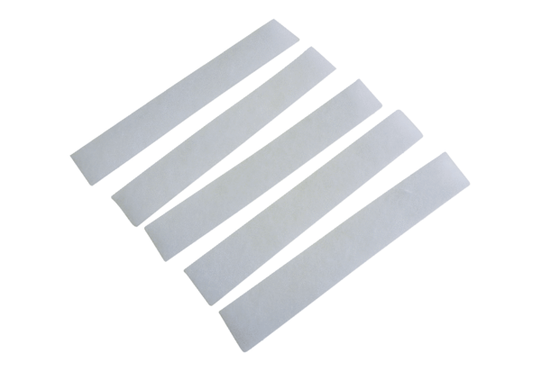Air filter, replacement ZF 17 SPacking unit: 5 piecesRange: B
Article number: 0093.0675Manufacturer: MAICO

