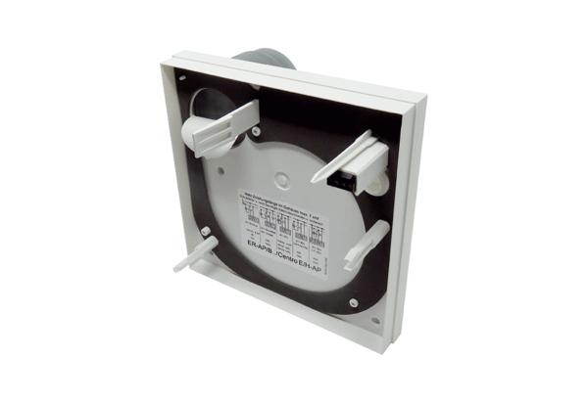Lower part of housing GHU ER-APB/Centro-APBRange: B
Article number: E059.1035.9200Manufacturer: MAICO

