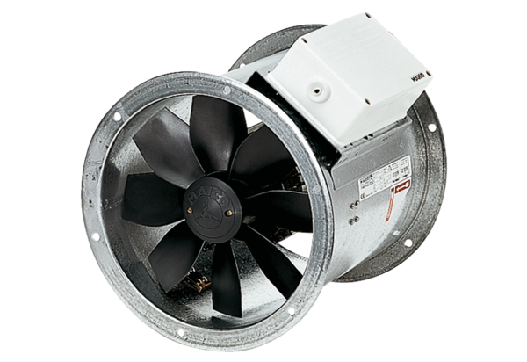Axial duct fan DZR 50/86 BPacking unit: 1 pieceRange: C
Article number: 0086.0067Manufacturer: MAICO

