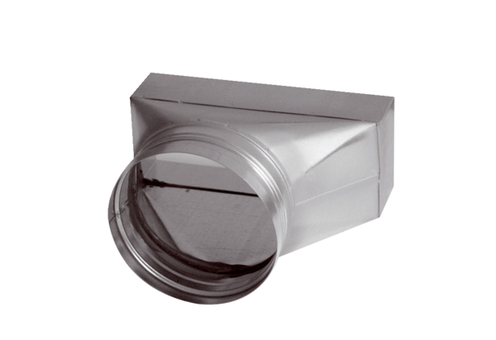Intermediate piece, asymmetric USAN80/200/125Packing unit: 1 pieceRange: K
Article number: 0055.0672Manufacturer: MAICO

