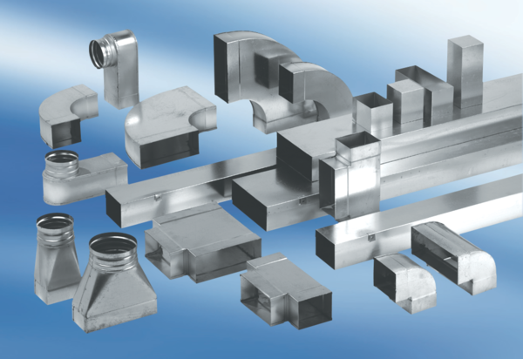Reducer, asymmetrical REDA80/150/55Packing unit: 1 pieceRange: K
Article number: 0055.0715Manufacturer: MAICO

