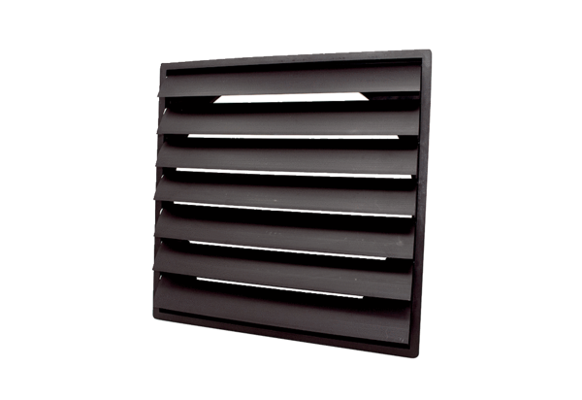Shutter AS 40 ExPacking unit: 1 pieceRange: C
Article number: 0151.0406Manufacturer: MAICO

