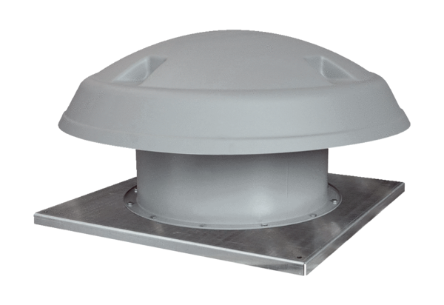Axial roof fan DAD 63/4Packing unit: 1 pieceRange: C
Article number: 0073.0074Manufacturer: MAICO

