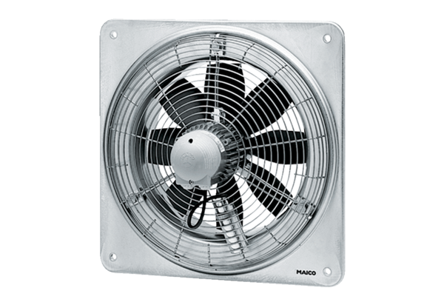Axial wall fan DZQ 40/84 BPacking unit: 1 pieceRange: C
Article number: 0083.0155Manufacturer: MAICO

