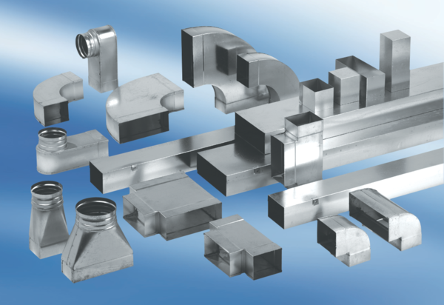40 mm channel sound absorbers with attenuating linging. KSD70/170/1200Packing unit: 1 pieceRange: K
Article number: 0092.0457Manufacturer: MAICO

