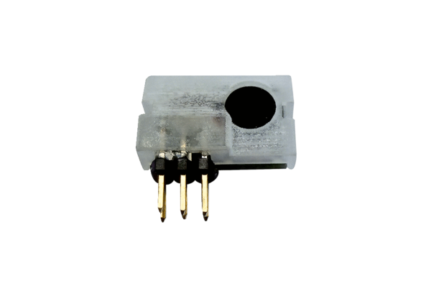Humidity sensor PP 45 HYIPacking unit: 1 pieceRange: K
Article number: 0157.0364Manufacturer: MAICO

