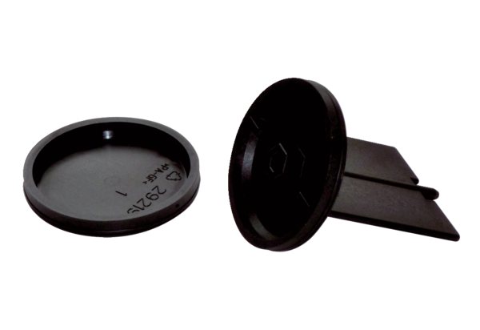Inlet element/cover set for air distributor FFS-V4EDPacking unit: 2 piecesRange: K
Article number: 0055.0897Manufacturer: MAICO

