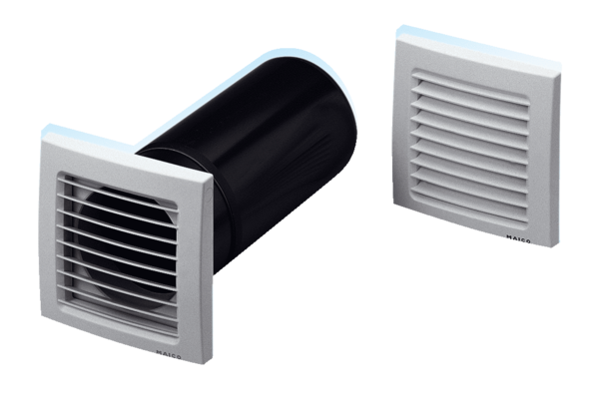Supply air element, uncontrolled ZE 10-1Packing unit: 1 pieceRange: D
Article number: 0152.0001Manufacturer: MAICO

