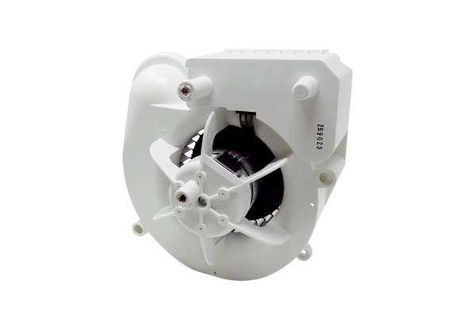Fan insert VE ER-AP 100 FRange: B
Article number: E084.0172.0000Manufacturer: MAICO

