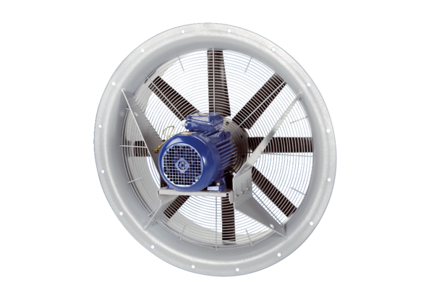Axial fan DAS 112/8Packing unit: 1 pieceRange: C
Article number: 0083.0863Manufacturer: MAICO

