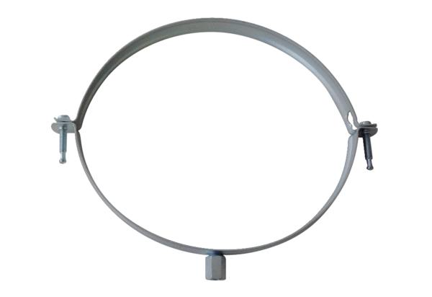Mounting clamp MT-LS160Packing unit: 1 pieceRange: K
Article number: 0018.0066Manufacturer: MAICO

