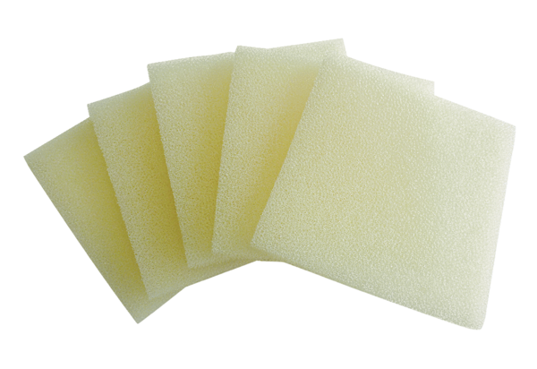Air filter, replacement ALDF 12 G2Packing unit: 5 piecesRange: B
Article number: 0093.0152Manufacturer: MAICO

