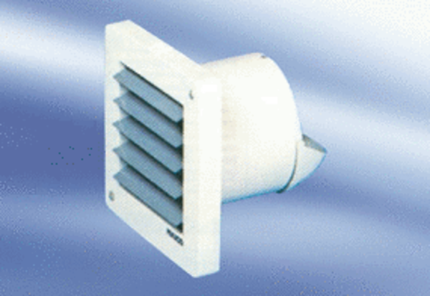Small room fan ECA 10-2Packing unit: 1 pieceRange:
Article number: 080026Manufacturer: MAICO

