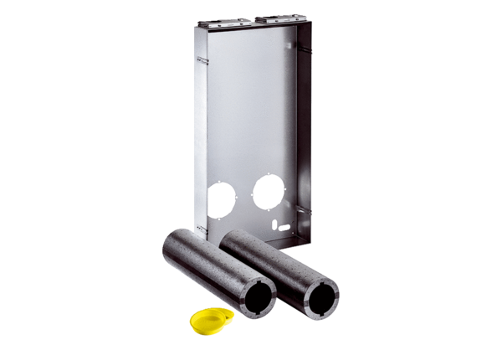shell installation kit Duo Z-SRPacking unit: 1 pieceRange: K
Article number: 0095.0333Manufacturer: MAICO

