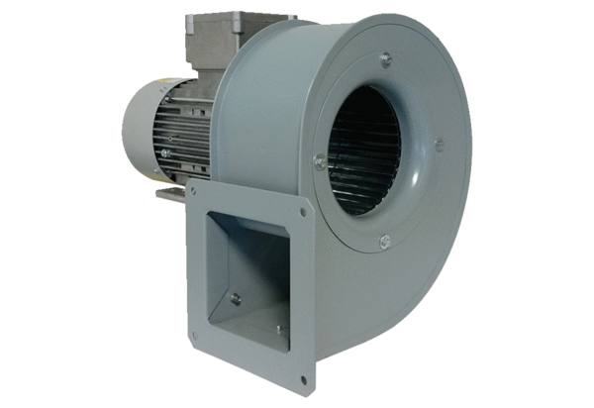Centrifugal blower GRM 10/2 D ExPacking unit: 1 pieceRange: C
Article number: 0073.0386Manufacturer: MAICO

