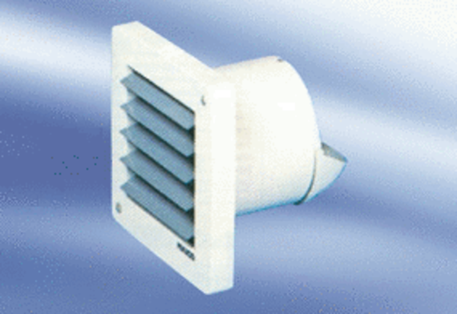Small room fan ECA 10-2 FPacking unit: 1 pieceRange:
Article number: 080172Manufacturer: MAICO

