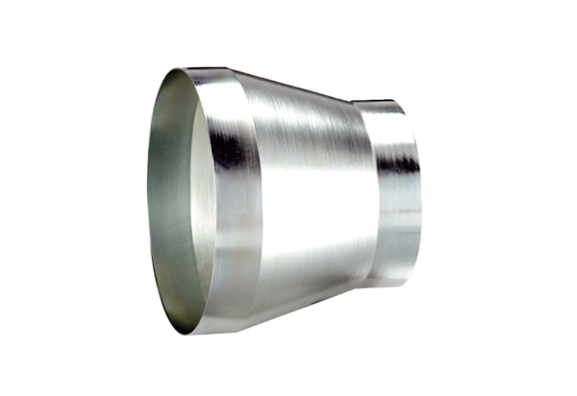Reducer REM 25/18 ExPacking unit: 1 pieceRange: C
Article number: 0055.0308Manufacturer: MAICO

