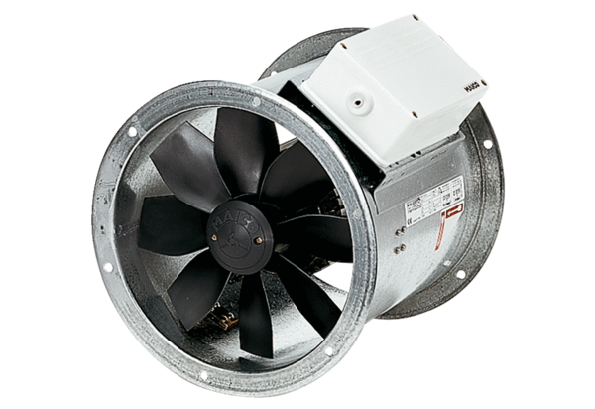Axial duct fan DZR 56/6 BPacking unit: 1 pieceRange: C
Article number: 0086.0063Manufacturer: MAICO

