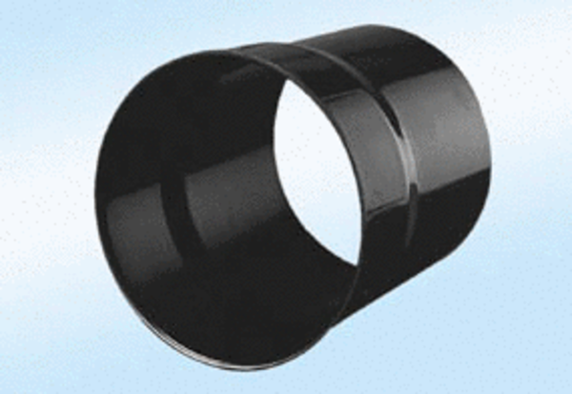Wall sleeve WH 20Packing unit: 1 pieceRange:
Article number: 0059.0229ALTManufacturer: MAICO

