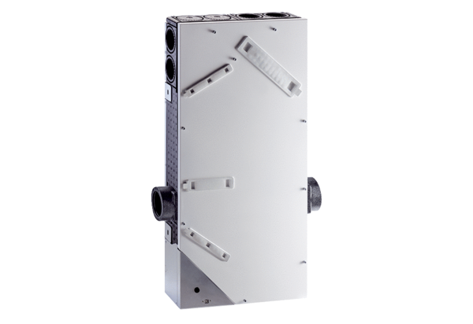Ventilation unit WS 75 Powerbox SPacking unit: 1 pieceRange: K
Article number: 0095.0645Manufacturer: MAICO

