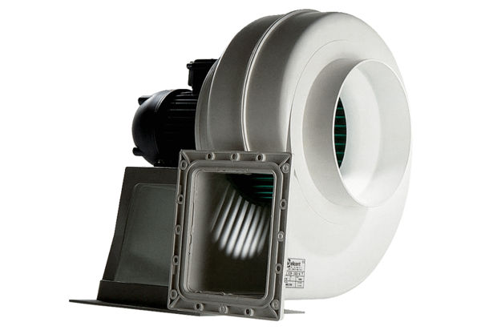Centrifugal blower GRK 20/4 DPacking unit: 1 pieceRange: C
Article number: 0073.0307Manufacturer: MAICO

