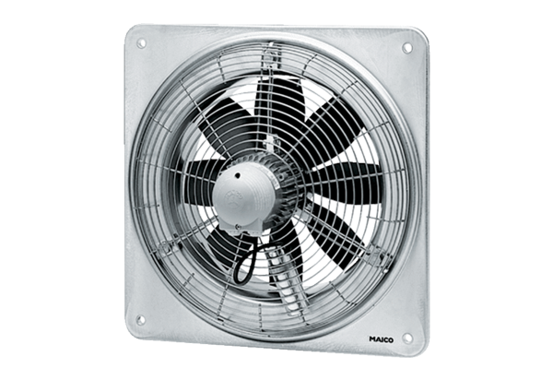Axial wall fan DZQ 30/64 BPacking unit: 1 pieceRange: C
Article number: 0083.0146Manufacturer: MAICO

