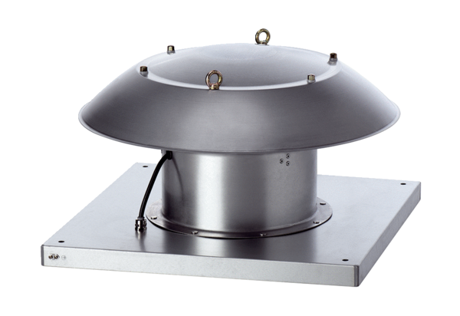Axial roof fan DZD 35/4 B Ex tPacking unit: 1 pieceRange: C
Article number: 0087.0816Manufacturer: MAICO

