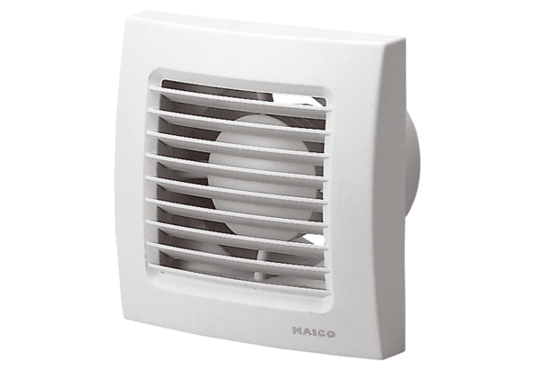Small room fan ECA 120 24 VPacking unit: 1 pieceRange: A
Article number: 0084.0019Manufacturer: MAICO

