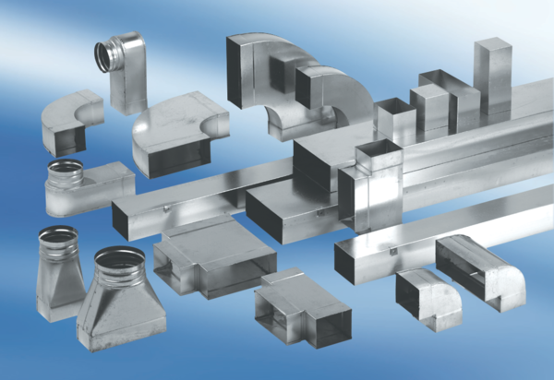45° channel elbows, vertical KB45V/80/150Packing unit: 1 pieceRange: K
Article number: 0055.0604Manufacturer: MAICO

