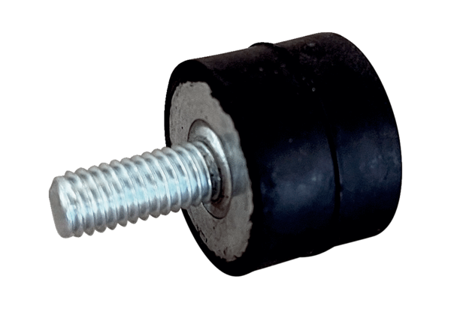Vibration damper GPI 10-20Packing unit: 1 pieceRange: C
Article number: 0073.0273Manufacturer: MAICO

