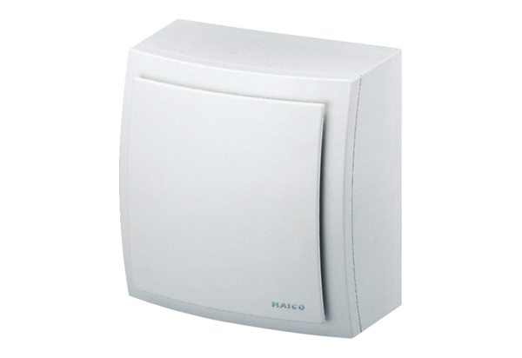Housing GH AP ER 60/100 FRange: B
Article number: E059.1036.9101Manufacturer: MAICO

