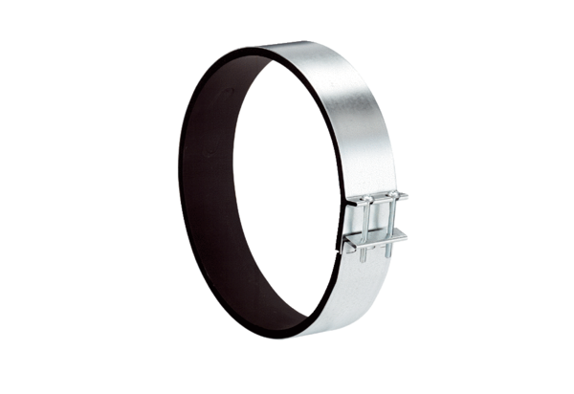Fixing cuff ELR 25Packing unit: 1 pieceRange: C
Article number: 0092.0113Manufacturer: MAICO

