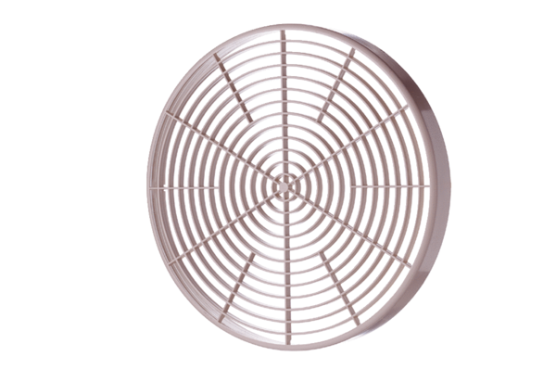Protective grille SGM 15Packing unit: 1 pieceRange: C
Article number: 0059.0425Manufacturer: MAICO

