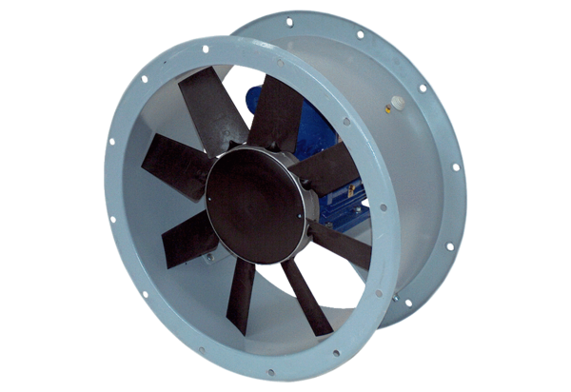Axial duct fan DAR 100/6-1 ExPacking unit: 1 pieceRange: C
Article number: 0073.0375Manufacturer: MAICO

