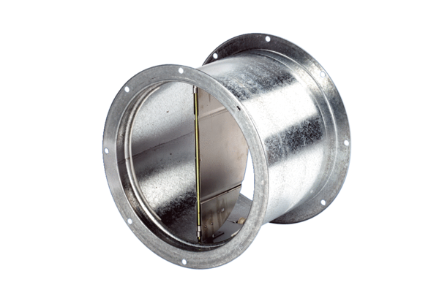Shutter VD 40Packing unit: 1 pieceRange: C
Article number: 0093.0104Manufacturer: MAICO

