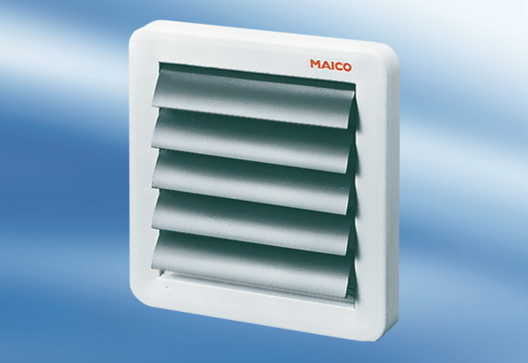AK 16Packing unit: 1 pieceRange: A
Article number: 0151.0038Manufacturer: MAICO

