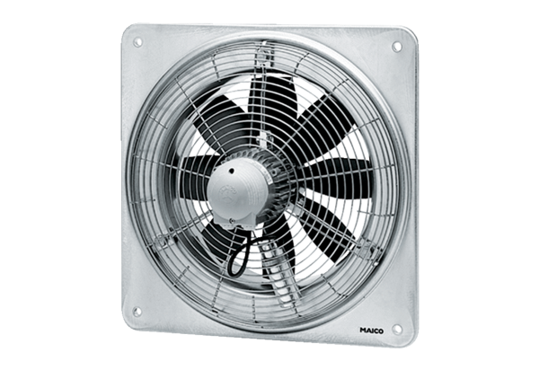Axial wall fan DZQ 50/64 BPacking unit: 1 pieceRange: C
Article number: 0083.0069Manufacturer: MAICO

