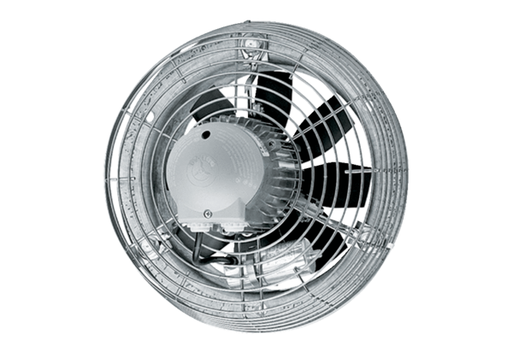Axial wall fan DZS 50/84 BPacking unit: 1 pieceRange: C
Article number: 0094.0054Manufacturer: MAICO

