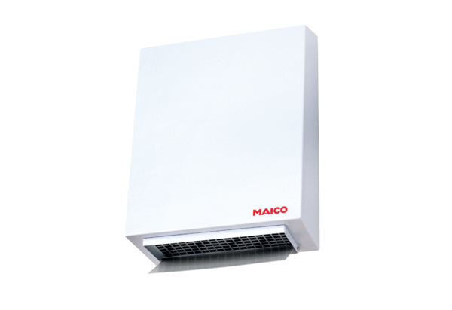Centrifugal external wall fan AWV 20 ECPacking unit: 1 pieceRange: E
Article number: 0073.0577Manufacturer: MAICO

